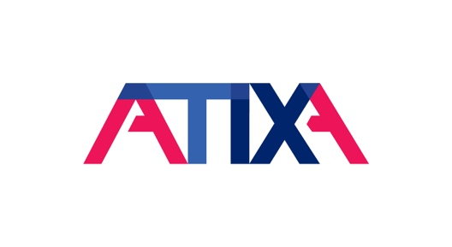
Date
From: [Your Name]
To: [Recipient Name]
Re: Request to Attend the 2021 Association of Title IX Administrators (ATIXA) Virtual Annual Conference
Dear [Recipient Name],
I would like to attend the 2021 ATIXA Virtual Annual Conference from October 19–20, 2021. Attending this Conference will be a valuable investment in my professional development.
This Conference will enable me to attend educational sessions that are directly applicable to my work as {your title}. ATIXA offers five tracks at their Conference: ADA/504 Issues, Advocacy/Prevention, Investigations, K-12 Arena, and Coordination. As an attendee, I will have the choice to attend sessions aligned with one track to receive targeted content in a specific of interest, or choose to move between sessions across multiple tracks to receive content in all areas. While the live Conference experience can be tailored based on interest, all attendees will receive access to each recorded sessions, so I will be able to access any valuable content missed during each live session.
ATIXA can have over 350 attendees at their virtual events, and their Annual Conference is the leading conference in the field of Title IX, sex and gender equity, and discrimination. Since there are so many professionals that also want to take advantage of ATIXA’s content at the Conference, this would be an opportunity to directly interact with other professionals in the field, share resources, and network. The opportunity for me to gain knowledge in specific areas, develop better contacts, and share best practices makes my attendance at the 2021 ATIXA Virtual Conference an investment that broadens my ability to assist {your organization} in becoming a compliant.
Sincerely,
[Name]
[Title]

